Benefits Claims Decision Support System (BCDSS)
Software Design Document



April 2016
Version 1.4

Department of Veterans Affairs

Revision History
Date | Version | Description | Author
4/29/2016 | 1.4 | Updated the Epics and Stories from the initial draft review | BCDSS Team
4/27/2016 | 1.3 | Created Baseline Document from Draft review comments | BCDSS Team
4/12/2016 | 1.2 | Requirements, Architecture, Database and Design Updates | BCDSS Team
04/05/2016 | 1.1 | Architecture and Design Updates | BCDSS Team
3/28/2016 | 1.0 | Template updates | BCDSS Team
3/24/2016 | 0.9 | Architecture, Database and Design Updates | BCDSS Team
2/07/2016 | 0.8 | Document Cleaned and Labeled | BCDSS Team
2/05/2016 | 0.7 | Figures, Tables Added, RTM Inserted | BCDSS Team
2/01/2016 | 0.6 | Architecture, Database, Security and Platform Design Updates | BCDSS Team
1/26/2016 | 0.5 | Data Dictionary Added | BCDSS Team
1/21/2016 | 0.4 | Context, Data, High-Level and Roles Updates | BCDSS Team
1/15/2016 | 0.3 | Database and Logical Design Updates | BCDSS Team
12/15/2015 | 0.2 | Architecture updates | BCDSS Team
11/09/2015 | 0.1 | Document Creation | BCDSS Team

Artifact Rationale
The Software Design Document (SDD) is a dual-use document that provides the conceptual design as well as the as-built design. The BCDSS team will update this document as the team builds the BCDSS System, to reflect the as-built product. The team based this document on the Project Management Accountability System (PMAS) ProPath Template.

Table of Contents
1. About this document 8
2. Introduction 8
2.1. Purpose of the SDD 8
2.2. Identification 8
2.3. Scope 9
2.4. User Profiles 9
2.4.1. Manage models 9
2.4.2. Ingest Claim Data 9
2.4.3. Populate Claims Data 9
2.4.4. Apply models 10
2.4.5. Review Results 10
2.4.6. Process Results 11
2.4.7. Reporting 11
2.4.8. User management 11
3. Background 11
3.1. Overview of the System 11
3.2. Overview of the Business Process 12
3.3. Assumptions and Constraints 19
3.3.1. Design Assumptions 19
3.3.2. Design Constraints 19
3.3.3. Design Trade-offs 20
3.4. Overview of the Significant Requirements 20
4. Conceptual Design 24
4.1. Conceptual Application Design 24
4.1.1. Service Oriented Architecture (SOA) approach 24
4.1.2. Application Context 25
4.1.3. High-Level Application Design 26
4.2. Conceptual Data Design 27
4.2.1. BCDSS Conceptual Data Model 27
4.2.2. The BCDSS CDM Data Dictionary 28
4.2.3. Database Information 29
4.3. Conceptual Infrastructure Design 30
4.3.1. System Criticality and High Availability 30
4.3.2. Special Technology 30
5. System Architecture 30
5.1. Application Architecture 31
5.1.1. User Interface 32
5.1.2. Business Services 33
5.1.3. Technical Services 33
5.1.4. Data Transformation Services 33
5.1.5. Data Services 33
5.1.6. External Interfaces 34
5.2. Hardware Architecture 34
5.3. Software Architecture 35
5.3.1. Access Layer 35
5.3.2. Application Layer 35
5.3.3. Persistence Layer 36
5.3.4. Security Layer 36
5.3.5. Database Layer 36
5.3.6. Infrastructure Layer 36
5.4. Continuous Integration / Continuous Delivery 36
5.5. Service Oriented Architecture / ESS 36
5.6. Enterprise Architecture 36
6. Data Design 37
6.1. DBMS Files 37
6.2. Non-DBMS Files 37
6.3. Data View 38
6.4. BCDSS Data Ingest and Processing (INPUT) 38
6.4.1. BCDSS Role Based Access Control (Model Repository) 42
6.4.2. BCDSS Predictive Model Meta Data 42
7. Detailed Design 43
7.1. Software Detailed Design 43
7.1.1. Application Dashboard 44
7.1.2. Server-side components 46
7.1.3. Manage Models 46
7.1.4. Display Target Claims 47
7.1.5. Apply Models to Target Claims 48
7.1.6. Reporting 48
7.2. Specific Requirements 49
8. Security and Privacy 49
8.1. Security 49
8.1.1. Physical Security 49
8.1.2. Network Security 49
8.1.3. Transport Security 49
8.1.4. Message Security 51
8.1.5. Application Security 51
8.1.5.1. Authentication 51
8.1.5.2. Authorization Design 51
8.2. Privacy 51
9. Human-Machine Interface 52
9.1. Interface Design Rules 52
9.2. Inputs 52
9.2.1. User Roles 52
9.3. Outputs 53
9.4. Navigation Hierarchy 53
9.4.1. Logon 53
9.4.2. Adjudication Start 54
9.4.3. Adjudication Results 55
10. Acronyms and Abbreviations 56
11. Approval Signatures 57
A. Additional Information 59
A.1. Identification of Technology and Standards 59
A.2. Constraining Policies, Directives and Procedures 60
A.3. Requirements Traceability Matrix 60
A.4. Packaging and Installation 61

About this document
The SDD describes the Benefits Claims Decision Support System (BCDSS) system requirements, operating environment, system architecture, database design, input formats, output formats, detailed design, processing logic, and external interfaces.

Introduction
In 2013, Compensation Service initiated a research effort to determine the feasibility of using predictive models to automate disability claims processing and focused on requests for increase claims. This research developed predictive models to forecast disability ratings based on the type of claim, Veteran characteristics, military service, demographic data, previous claims history and ratings, and other key parameters.
To date Compensation Service have focused research on producing predictive models for rating disability claims for the hearing and knee body systems, which represent the highest frequency of disabilities claimed. The Veterans Benefits Administration (VBA) is seeking to create a software platform to implement predictive models to rate historical disability claims.
The Veterans Affairs (VA) established the BCDSS project to demonstrate the feasibility of using automation and predictive models to calculate the combined disability determination (CDD) for specific conditions contained within Veteran claims for disability compensation. Such capabilities could help the VA improve the quality and consistency of its current claims adjudication decisions, and potentially could provide Veterans with the ability to obtain the likely outcome of their claims for benefits at the time of filing. Both outcomes could significantly improve the veteran experience and the efficiency of VA’s claims adjudication process.

Purpose of the SDD
The purpose of this document is to describe in sufficient detail how the proposed system will be constructed. The SDD translates requirement specifications into a document from which the developers can utilize to create the actual system. It identifies the top-level system architecture, and establishes hardware, software, communication, and interface components. For the purpose of this document, “system” will be used to reference the overall BCDSS solution (UI/UX, Database, Models, Modeling Engine, and Services) and “application” will be used to reference the portions of BCDSS that will interface with an end user (UI/UX).

Identification
This SDD applies to the BCDSS as developed under the purview of the VA Center for Innovation (VACI).

Scope
The BCDSS SDD describes the architecture, functional components, and interfaces of the BCDSS including the:
- BCDSS Database – Application will use RDBMS and NoSQL to implement the modeling, staging, and reporting repositories of the system
- Predictive Models for Ear and Knee – models used when performing the predictive analytics
- Modeling Engine – The engine performing the analysis of the Claim data utilizing the models
- System Administration – UI/UX allowing administrators the ability to control access to the BCDSS application and to perform other administrative actions
- Dashboard – UI/UX allowing users to select Claims to process against selected models and view the results
- Model Management – UI/UX allowing Model Agents the ability to track CRUD (create, read, update, and delete) requests for models and to publish available models for use
This document should be read in conjunction with the BCDSS Requirement Traceability Matrix (RTM) and Requirements Document.

User Profiles
There are eight user interaction scenarios envisioned: manage models, select claims, apply models to selected claims, review and process results, reporting, and user management. Descriptions of these scenarios as envisioned follow below:

Manage models
The primary users in this usage model are the VA Modeling Agent teams. The BCDSS application allows modeling agent users to make controlled edits to existing models within the system. The user identifies what models should be ingested into the system. The application will execute a routine that verifies that a new model conforms to system specifications.

Ingest Claim Data
The primary users in this usage model are the VA Modeling Agent teams. The BCDSS application allows modeling agent users to search for claims data from a pre-loaded and scrubbed data set provided by the VA. The application utilizes a mock web service to search this data to simulate the production environment.

Populate Claims Data
The primary users in this usage model are the VA Rater teams. The BCDSS application gets the claims data from a Mock webservice repository based on the user defined filter criteria. The BCDSS application is not going to integrate with the real-time VBMS web services as part of the pilot implementation. Instead mock services will be developed by BCDSS team to test the service integration. The user selects claim(s) from the list to perform further actions. The below diagram (Figure 1) explains the mock webservice integration with BCDSS application service integration component.

Figure 1: Populate Claims Data

Apply models
The primary users in this usage model are the VA Rater teams. The BCDSS application displays available models that the VA Rater will then select to process and analyze the selected claims.

Review Results
The primary users in this usage model are the VA Rater teams. The BCDSS application will provide an interface for these users to perform required review results and perform other validations and actions on the model results.

Process Results
The primary users in this usage model are the VA Rater teams. The BCDSS application will provide an interface to persist results into the modeling repository.

Reporting
This model shall include both direct and indirect users. The direct users are the individuals required to generate reports. The indirect users are the consumers or target audience of the reports. The direct users will utilize the interfaces provided by the BCDSS application to generate reports and download in CSV or PDF format for indirect users.

User management
The primary users in this model are application administrators. The application will provide the capability for administrators to add/edit/delete users, permissions, and other application configurations.

Background

Overview of the System
The BCDSS system is responsible for the ingestion of VA historical claims data and the current claim for the application of a predictive model for the automated claim adjudication and rating. The solution applies predictive models (ear and knee) stored within a managed library, to claims with related historical claimant data to produce issue-specific Combined Disability Determinations (CDDs) for supplemental claims for increases. If BCDSS proves to be operationally viable and beneficial, the system’s design will allow easy integration within the VBA’s production claims adjudication process by enabling authorized personnel to apply the calculated ratings consistent with corresponding policy, guidance, and appropriate circumstances.
As shown in Figure 1, BCDSS will be an integrated and services based system comprised of the following:

- BCDSS Database - BCDSS will use RDBMS (Oracle) and NoSQL (MongoDB) to implement the modeling, staging and reporting repositories of the system. NoSQL (MongoDB) will be use as part of the solutions in the future which will allow BCDS users to easily make changes to the predictive models and the associated matrix data set without making extensive application code changes.

- Predictive Models - BCDSS Predictive models are used to forecast disability ratings based on the type of claim, veteran characteristics, military service, demographic data, previous claims history and ratings, and other key parameters.

- Modeling Engine - Modeling engine provides modeling logic for ingesting claimant data sets, determining whether the predictive models can be applied or not.

- Administrative Modules - Administrative modules provide interface to manage users, user permissions, data configurations required for the system.

- Dashboard - A dashboard is a set of graphical menus and interfaces that give the user quick access to various functions for an application. In most cases, dashboards contain information such as messages, statistics, schedules and analytics.
Fig 2 target claims contain shows input to Dashboard. Wouldn’t it be to BCDSS DB?
Figure 2 – Business process overview.

Overview of the Business Process
Section 2.4 of this document outlines the major use cases associated with the BCDSS application. Of these use cases, the ones with the most significant business process component are Apply Models and Process Results. The business process diagrams, Figure 3 through Figure 7, represent a high level overview of how the BCDSS application will integrate within these use cases, however it should be noted that the details of each business process may vary on a case by case basis. As we identify more business processes during the development process, this document will be updated.
The below process model illustrates the approach for deriving the ear and knee models and storage of these two models in the BCDSS application data repository. The BCDSS platform executes these models against claims to produce a report for user analysis of model results.
Figure 3 – Business process overview.
Figure 4 - Incorporating New Models and Apply Models to Target claims.

Figure 5 - Create New Models
Figure 6 - Apply Models to target claims.
Figure 7 – User permissions (Sub-process)
Table 1: Business process steps
Step | Name | Type | Description | Next Step | Requirements
MA 1 | List All models | User Task | User retrieves all available models | This step has 3 possible outcomes:  -Create or Updates models.  -Validate models  -Review models.
MA 2 | Fetch models | System task | System fetches models based on the user permissions | Proceed step MA 3
MA 3 | Establish/Modify models | User Task | The user can create or update models | Proceed step MA 4
MA 4 | Create new model request | User Task | Admin user initiates a new model request | Proceed step MA 5
MA 5 | Create model structure | System Task | System creates model structure and populates meta data | Proceed step MA 6
MA 6 | Validate Models | User task | User validates newly created models | Proceed step MA 7
MA 7 | Execute test data | System task | System executes test data | Proceed step MA 8
MA 8 | Compare to thresholds | System task | System compares the recommended ratings produced by the models to the actual historical rating. | Proceed step MA 9
MA 9 | Review | User task | User reviews the model | Proceed step MA 10
MA 10 | Validation | User task | User validates the model | This process step has two possible outcomes:  - Approve model  - Disapprove model  Proceed Step 11
MA 11 | Approve | User Task | User approves the model | Proceed step 12
MA 12 | Store Model | System task | System persists model in the model repository | End Event.
M1 | Search / Select a target claim | User task | The user selects a target claim | Process step M2
M2 | Get Target Claim data | System Task | System invokes Mock Web service for inbound claims data | Process Step M 3
M 3 | Call VBMS Shared Web service | System Task – External interface Integration | System communicates to external interface | Process Step M 4
M 4 | Choose Models | User Task | The user selects a model | Process step M 5
M 5 | Filter data | System task | The system filters data against model, type and version | Process step M 6
M 6 | Process Claims | User Tasks | User selects model and claims to process claims | Process step M 7
M 7 | Transform data | System Task | Transform input data and apply rating calculations | Process step M 8
M 8 | Matching and testing | System Task | The system matches/compares rating data. Testing is optional step. | Process step M 9
M 9 | Review | User Task | User reviews the final result | Process step M 10
M 10 | Generate Report | User Task | The user accepts all selections and generate a report | End Event. Proceed to next step.
A 1 | Manage user | User task | Create/Update/Delete a new user | Proceed step A2
A 2 | Persist user | System task | System stores user data | Proceed step A3
A 3 | Assign Permissions | User task | Admin user assigns permissions to the newly created user | Proceed step A 4
A 4 | Persist user permissions | System Task | System stores user permissions | End event.

Assumptions and Constraints
The details of the system design are subject to change as requirements are being gathered in parallel within an agile development cycle.
This SDD will be regularly updated and identified with version numbers to describe the expanded system design.
Unless otherwise stated, software will be open source and compliant with One-VA's Technical Reference Model (TRM).

Design Assumptions
The overall design and development process is based on iterative development and rapid prototyping, incorporating key stakeholder input allowing for design factoring and enhancement.

Design Constraints
- System designers have attempted to utilize open source tools wherever possible, including the design of the user interface, testing tools, and analytics tools.
- System designers used VA tools approved for use in the One-VA Technical Reference Model (TRM) List of Technology or have requested a waiver for any tools not listed on the TRM List of Technology.

Design Trade-offs
It is the system’s responsibility to provide a feature-rich and responsive Dashboard UI. The Predictive Models provide the analysis to drive the UI. Assuming that the number of users will be relatively low but the responsiveness of the Model processing is essential. Thus, the BCDSS Application is architected to scale by ensuring that performance does not degrade as the number of users increases and as additional data becomes available. This architectural focus can be demonstrated in the following design trade-offs:
- Maximize the responsiveness of the UI by utilizing client side controllers, and only making network calls to retrieve data. This is achieved through the use of a Single Page Application.
- Favor an asynchronous API interface to maximize performance. If an API call is synchronous, it means that code execution will block (or wait) for the API call to return before continuing causing possible performance issues. However, asynchronous calls do not block (or wait) for the API call to return from the server allowing execution to continue in the application.
- We will use Oracle database for modeling, staging and reporting repositories as part of pilot development scope. NoSQL will be used as part of a future solution.
- Favor the usage of micro-services, rather than traditional web server clusters, to maximize discrete scalability options and to ensure that services remain loosely coupled.

Overview of the Significant Requirements
The table below includes an overview of the major user requirements associated with the proposed solution. A full listing of the project’s Product Backlog is maintained in JIRA at https://bcdssteam.atlassian.net/issues/?jql=
In addition, a more detailed snapshot of the project’s major functional requirements will be included in the project’s RTM. The VABCDS tags in the table below, for example, “VABCDS-173,” derive from the tracking system in Jira.
Table 2: Epics and User Stories

JIRA Key | Epic | User Story
VABCDS-173 | As a User, I want to login into the BCDS application, So that I can utilize predictive models to rate VA disability claims | As a User, I want to login into the BCDS application, So that I can utilize predictive models to rate VA disability claims
VABCDS-174 | As an BCDS Team member, I need the capability to manage users access to the system, so that "Modeler", "Modeling Agent" and "Administrator" can perform their respective tasks  System User Roles -  Administrator  Model Agent  Modeler | As a Rater, I need the ability to access the BCDS Application, So that I can use the predictive ratings in progress and be able to access all claim information
 |  | As a Modeling Agent, I need the ability to access the BCDS Application, so that I can create, update, delete and review predictive models.
VABCDS-175 | As an Administrator, I need the capability to manage users, so that I can manage user accounts based on the needs | As an Administrator, I need the ability to manage user access to the System, so that I can provide and control access to the BCDS application
VABCDS-176 | As a User, I need to be able to view and access the dashboard so that I can perform my daily operations | As a Rater, I need the ability to have a dashboard, So that I can access all claim information, choose models, review and generate reports, and perform ratings against models.
 |  | As a Modeling Agent, I need the ability to have a dashboard so that I can create, update, delete and review predictive models and review the progress of the processed claims
 |  | As a Rater, I want to retrieve Veteran's claims so that I can run predictive model on it based on the contention
VABCDS-177 | As a Rater, I need the system to show the respective disability predictive model based on the contention So that I may approve the predicted disability | As a Rater, I need the system to show the respective disability predictive model based on the contention So that I can Predict the compensation for the disability
 |  | As a Rater, I need the system to show an alert in case the predictive model is not available for the selected contention, So that it can be handled accordingly
VABCDS-178 | As a Rater, I need the ability to process each contention of Claim/disability separately so that I can rate the disability appropriately. | As a Rater, I need to be able to process each contention of the claim separately so that I can predict and evaluate each contention's rating output
VABCDS-179 | As a Rater, I need to view the Predictive Results/output, so that I can verify the accuracy of the Rating | As a Modeler,I need to view the output of the Predictive Model, So that I can compare it with the actual Rating output
 |  | As a Modeler,I need to be able to store the Predictive models results in the BCDS Model repositorySo that I can use it in future
VABCDS-180 | As a Rater, I need the system to have the capability to receive feeds from new supplemental claims requesting increase in compensation for the previously rated claim, so that the supplemental claim for increase could be predicted using the predictive model | As a Modeler, I need the system to have the capability to receive feeds from new supplemental claims for "disability of the Ear" and "Knee" (received from the Veterans) requesting increase in compensation for the previously rated claim, so that the supplemental claim for increase for disabilities of the Ear and Knee could be predicted using the predictive model
VABCDS-181 | As a Rater, I need the system to have the capability to identify which all contention on each claim can be rated by Predictive Models, so that I can rate those contentions using the respective predictive model | As a Rater, I need the system to have the capability to identify which all contention on each claim can be rated using the Predictive Model, so that I can rate those contentions using the respective predictive model
VABCDS-182 | As a Rater, I need the System to have the capability to Retrieve and display data from the Veteran's claim history, claim text, and Veteran Demographic, so that it's available in the system and could be viewed as needed | As a Rater, I need the BCDS System to have the capability to retrieve and display data from the Veteran's claim history, claim text, and Veteran Demographic information, so that it's available in the BCDS system and could be viewed when needed
VABCDS-183 | As a Rater, I need the system to orchestrate the models and corresponding data and find appropriate pattern match from DDM, so that I can obtain predictive rating | As a Rater, I need the system to orchestrate the models and corresponding data and find appropriate pattern match from DDM, so that I can obtain predictive rating
VABCDS-185 | As a Modeling Agent,  I need the system to have the capability to keep the "Model Logic" separate from "Platform code", so that I can Edit "Model Logic" and "Platform Code" independently | As a Modeling Agent,I need the system to have the capability to keep the "Model Logic" separate from "Platform code", so that "Model Logic" and "Platform Code" could be edited independently
 |  | As a Modeling Agent,I need the system to have the capability to allow to author, modify and manage the Model Logics and Platform independently, so that I can make changes to Model logic and Platform Logic without depending on the BCDS system developers
VABCDS-186 | As a Rater, I need the system to have the capability to produce report for viewing for each rated contention with the details of analysis how the BCDS system recommended rating was achieved and all the relevant supporting information, so that I can understand and validate the model rating produced by BCDS | As a Rater, I need the system to have the capability to produce report for viewing for each rated contention with the details of analysis how the BCDS system recommended rating was achieved and all the relevant supporting information, so that I can understand and validate the model rating produced by BCDS
VABCDS-187 | As a Rater, I need the system to have the capability to generate, display and store the Report, so that I can review the output and be able to associate it to the Veteran's file in eFolder for later use | As a Rater, I need the system to generate the report and display the report for each rated contention in a format that’s compatible to be accepted by eFolder, so that I can review and analyze the output
 |  | As a Rater, I need the ability to save the generated analysis report to the local system so that I may store the report to eFolder where needed
VABCDS-213 | As a BCDS Team member,  I need to have a mechanism built into the application to compare the BCDS generated predictive rating with that of the actual ratings, So that I can compare the Predictive Ratings with the Actual Ratings | As a BCDS Team member,  I need to have a mechanism built into the application to compare the BCDS generated predictive rating with that of the actual ratings

Conceptual Design

Conceptual Application Design
The BCDSS application applies the principle of a Service Oriented Architecture (SOA) based architecture for an interface based design approach. This approach provides a logical partition of the separation of concerns of the system allowing back-end implementations to change without affecting the entire system. The BCDSS application architecture can be represented in the following layers illustrated by Figure 8:
Figure 8 – Application design.

.

Service Oriented Architecture (SOA) approach
The BCDSS system will implement a SOA. This approach provides a flexible and scalable architecture that allows BCDSS to support the unique needs of the technical implementation. SOA enables the solution to focus on implementing business solutions rather than application or technical solutions.

SOA is a process-centric architecture. It provides the capability to assemble discrete services in such a way to deliver distinctive business services and capabilities. The functionality is distributed across services, rather than building business logic directly into an application.
Integration of functionality occurs at the process-level, not the application-level. This allows flexibility in design and the agility to adjust as business needs change and organizations look to optimize business processes.

In building a SOA, there are two primary considerations:
- How to integrate both internal and external services, applications and systems
- How to build business processes to deliver business capabilities

Application Context
While traditional ratings must remain in place, this proposed approach introduces other tool for the RVSRs to utilize. The BCDSS solution is a cutting-edge approach to add efficiencies to the ratings process already in place at the VA. The BCDSS application context components are illustrated in the Figure 9 and components description explained in Table 4.

Figure 9: System Architecture

Table 4: Application Context Description
Name | Description | Interface Name | Interface System
Application Dashboard | Application dashboard provides set of graphical menus and interfaces that give the user quick access to various functions for an application | HTTP(s) and SQL query | VA Users
Predictive Models | This component provides the established predictive models to determine ratings for issues contained within relevant claimant data sets. | HTTP(s) and SQL query | Modeling Engine
Modeling Engine | This component provides the platform and modeling logic for ingesting claimant data sets, determining whether the predictive models can be applied, applying the predictive models, and outputting either auto-rated issues and the related report for the claimant data set, or the ineligible issues for the claimant data set. | SOAP and SQL query | BCDSS Database, Mock Webservice
Reports | This component provides information to the users on the data ingest and auto-adjudication system output using predefined format. Users will be able to download reports into CSV and PDF formats to their local systems. | SQL Query | BCDSS Database
BCDSS Database | This component stores statistically relevant enterprise data supporting current and future predictive models. These data will be used to formulate, validate, and refine current and future predictive models. This component also maintains users and role-based security information. | SQL Query | Oracle Database
External VA Interface | This component allows authorized users to get the target claims data from VBMS system. | SOAP | VBMS System

High-Level Application Design
The BCDSS application uses Angular.js as client side technology and will handle all the request flow from client side pages to server side. It uses Node.js as a server side technology that will handle processes such as loading an application with all the required packages, and make a server for handling any HTTP request for web application. Express.js will be used for Rest based web services.
All server-side business components are developed using ReST API, Java/Spring technology and service integration components are developed using Java, ReST, and SOAP.
Java/spring framework components are used to manage the data flow between the layers. We will utilize Java for simple objects that provide utilities to the application, as well as to implement business logic such as application rules, calculations, validations etc., and provide other supporting services such as interfaces between BCDSS and Mock Webservices.

The Figure 10 illustrates the high-level design approach of the BCDSS application that processes claims against models to produce a report for user analysis of model results.

Figure 10 – High-level Application design.

Conceptual Data Design

BCDSS Conceptual Data Model
Figure 11 is the BCDSS that defines the high level business entities that support the BCDSS business process for predicting benefit rating. It captures the course level information for what the system needs to rate a claim and the results of the predictive model for reporting. It also addresses the high level information for how the application will manage security for users.

Figure 11: BCDSS Conceptual Data Model
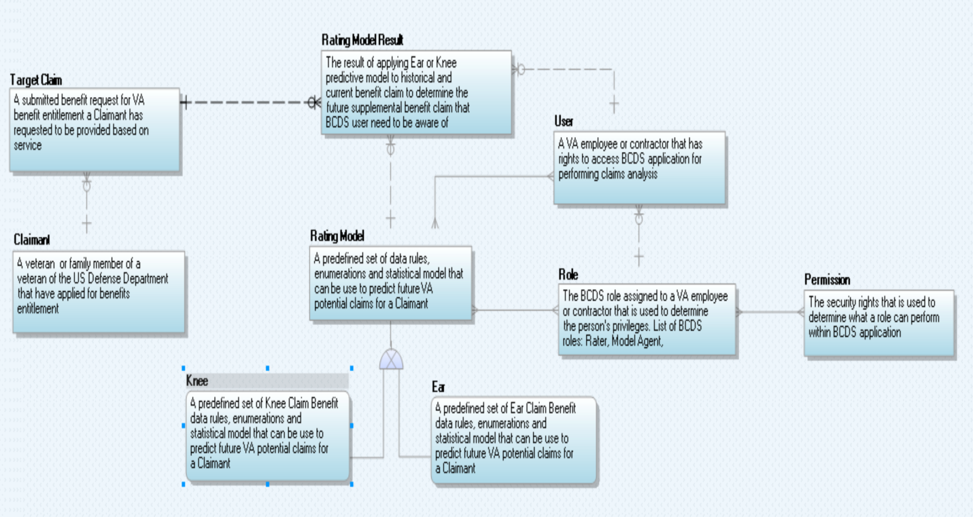

The BCDSS CDM Data Dictionary
The outline below, Table 5, is the data dictionary that defines each of the high-level business entities.
Table 5 – BCDSS Data Dictionary

Data Object | Type | Description
User | Entity | A VA employee or contractor that has rights to access BCDSS application for performing claims analysis
Ear | Entity | A predefined set of Ear Claim Benefit data rules, enumerations and statistical model that can be used to predict future VA potential claims for a Claimant
Knee | Entity | A predefined set of Knee Claim Benefit data rules, enumerations and statistical model that can be used to predict future VA potential claims for a Claimant
Rating Model | Entity | A predefined set of data rules, enumerations and statistical model that can be used to predict future VA potential claims for a Claimant
Target Claim | Entity | A submitted benefit request for VA benefit entitlement a Claimant has requested to be provided based on service to be rated using predictive models
Claimant | Entity | A veteran or family member of a veteran of the US Defense Department that have applied for benefits entitlement
Role | Entity | The BCDSS role assigned to a VA employee or contractor that is used to determine the person's privileges. List of BCDSS roles: Rater, Model Agent, Administrator, Modeling Analyst
Rating Model Result | Entity | A predefined set of data rules, enumerations and statistical model that can be used to predict future VA potential claims for a Claimant
Permission | Entity | The security rights that is used to determine what a role can perform within BCDSS application

Database Information
Table 6 lists the logical data repositories that BCDS will use for acquiring, processing and providing reporting functionality to users.
Table 6: Database Inventory

Database Name | Description | Type | Steward
Model Repository | A data repository responsible for persisting Ear & Knee predictive models and the associated data for operation of BCDSS Application | NoSQL DB (MongoDB) | TBD
Reporting Repository | A data repository responsible for persisting the results of the predictive model and ratings determination for reporting and analysis purpose | Relational Database Management System (RDBMS) - Oracle | TBD
Staging Repository (INPUTE) | A data repository responsible for staging of data and preparation of data and predictive models before processing | Relational Database Management System (RDBMS) – Oracle  &  Hadoop HDFS | TBD

Conceptual Infrastructure Design
The architecture of this system supports cloud computing and the principles of OneVA Enterprise Architecture (OneVA EA). The BCDSS system is intended to be implemented on a virtual or single cloud resource.

System Criticality and High Availability
The BCDSS is not a high availability system. System redundancy is not a requirement within this innovation program at this time. The availability of this system is expected to be 99.9% uptime with the exceptions of the times when the underlying infrastructures are not available due to maintenance.

Special Technology
As the BCDSS Innovation requires addition of and is granted approval or waivers for any special technologies listed below, Table 7 will be updated.
Table 7: Special Technology Requirements
Special Technology | Description | Location | TRM Status

System Architecture
The system developed under the BCDSS project will be designed to run on a cloud-based environment consistent with the principles of OneVA EA. The following diagram (also shown in Section 4.1.2) provides an overview of the System Architecture.

Figure 12: System Architecture

Application Architecture
The application architecture describes how various components of the BCDSS Solution are integrated with each other to build an integrated application. The BCDSS is multi-tiered, modular, and rule based application. The application is based on the principles of SOA, and employing open standards for interfaces making it configurable to meet VBA requirements.
Figure 13 – Application architecture.

In Figure 13 above, service components are built for interoperability. Services adhere to the Web Services Interoperability (WS-I) standard and are based on the Service Contract Specification. Services within this layer are classified into the following categories.

User Interface
The User Interface Layer provides graphical user interfaces to application users to access services through various access channels.
The BCDSS system is a web-based application that will utilize an approved and modern framework of technologies. At the lowest level, HTML 5 provides the basic markup language, facilitating cross-platform rendering. Cascade Styling Sheets (CSS) modularize and abstract the styling presentation away from the content represented within HTML 5. Java Script (JS) provides dynamic interface capabilities and service interaction. Development interaction with the lower levels of the presentation layer are managed using two primary frameworks. The first one is Twitter Bootstrap, which provides common UI components comprised from pre-defined HTML and CSS compositions. The second one is AngularJS, a popular JS based framework utilizing a declarative approach to providing development of a user interface.

Business Services
Business Services encapsulate the application and business logic that supports BCDSS business functions. Services within this layer are invoked in various methods. Trusted application components and services in other architecture layers may invoke services directly via open Java EE-compliant application interfaces (APIs). This method of invocation is often preferred for performance reasons when both the consumer and provider are known and within trusted zones, are both contained within the BCDSS system boundary, or exist within the same Java container.
Rules Services within solution provide the encapsulation and isolation of business rules logic for implementing policy and complex rules.
Report service provides BCDSS Application Reports from the BCDSS Model repository using SQL queries.

Technical Services
Technical services include common architecture services (such as batch management, auditing, and exception handling) and those services used by applications to access the core set of functionality provided by other software. This software is plugged into the BCDSS framework, including business rules management and reporting functionalities.

Data Transformation Services
Data Transformation services are used to process the data from one format, such as XML or SOAP, into another. The data transformation service transforms target claims data from Mock Webservices to the BCDSS application components.

Data Services
Data Services provide the application access to shared data. The Data Services components are written in Java and use open standards and specifications. The Data Services are coded to the Java Persistence API (JPA), a data management framework, and employ object to relational mapping techniques to access data within the underlying Database Management System (DBMS).
Data services will be developed to expose the results of predictive models processing, as well as, the accuracy of the models. Data services regarding:
- Properties and meta data of the predictive models within the platform repository will use MongoDB as the underlying data store for serving this type of information to external systems
- Results of processing target claims against predictive models will be exposed via data services.

External Interfaces
The solution’s first implementation is for a Prototype within the VA’s FTL-GC Sandbox (Amazon-based) cloud environment. BCDSS application will not integrate with the real-time VBMS web services as part of the pilot implementation. Instead, Mock web services will be developed by the BCDSS team to test the service integration.

Hardware Architecture
The BCDSS system will initially be deployed within the VA Cloud Integration environment. The Table 8 explains various hardware components required for Dev and Test environments.
Table 8 : BCDSS Hardware Configuration

Hardware Item # | Hardware Item | Environment | Description | Operating System | Count
1 | Web servers | Dev | Apache HTTP server 8GB RAM and 100 GB Storage | Windows | 1
2 | Application Servers | Dev | Tomcat and Reports server 8 GB RAM and 100GB Storage | Windows | 1
3 | Database Server | Dev | Oracle 11g Database 8 GB RAM and 200 GB Storage | Windows | 1
4 | Web servers | Test | Apache HTTP server 8GB RAM and 100 GB Storage | Windows | 1
5 | Application Servers | Test | Tomcat and Reports server 16 GB RAM and 100GB Storage | Windows | 1
6 | Database Server | Test | Oracle 11g Database 8 GB RAM and 200GB Storage | Windows | 1

Software Architecture
The BCDSS enterprise web application is a lightweight, browser-based application that does not require installation of other software on the user's desktop. The Figure 14 below depicts BCDSS software architecture approach provides a clean separation between the presentation and application layers. The web application is browser-independent and is designed to operate on Internet Explorer 11, with only minimal hardware related requirements.

Figure 14 – Software architecture

Access Layer
The Access layer provides interfaces to application users to access services through various channels. Access to the applications will be provided through Web Application and External Interface integration.

Application Layer
Application layer consists of system specific business services, which encapsulate the application and business logic that supports BCDSS business functions.

Persistence Layer
The Persistence layer or Data services layer provides the application access to shared data. The BCDSS data services components will be developed using Java Persistence API (JPA), a data management framework and employ object to relational mapping techniques to access data within underlying relational database management system (RDBMS).

Security Layer
Security services represent a specialized form of architecture services that provide applications with a vendor agnostic approach to performing authentication and access management actions. The identity and access management integration is out of scope for the current BCDSS pilot application. The application provides only role-based access control that determines if the user can access the requested resource. The security services will be developed using Spring security and implemented using custom Java components.

Database Layer
The database layer provides secure, integrated, and consistent access to system data using Oracle and NoSQL databases. Updates to data in any particular data store can only be made by business logic in the BCDSS application.

Infrastructure Layer
The infrastructure layer describes the overall capabilities provided by the infrastructure and the products supporting those services.

Continuous Integration / Continuous Delivery
The BCDSS solution will be maintained through a Continuous Integration / Continuous Delivery process (CI). This will isolate changes as they are added to the larger code base and are immediately tested and reported on. The goal of CI is to provide rapid feedback so that if a defect is introduced into the code base, it can be identified and corrected as soon as possible.

Service Oriented Architecture / ESS
While the BCDSS system may be extended to provide the predictive analytics as an Enterprise Shared Services in the future, the innovation objectives do not include the delivery of web services functionality.

Enterprise Architecture
The BCDSS application conforms to the principles of OneVA Enterprise Architecture, utilizing technologies approved on the VA TRM, open and standardized interfaces. Through standard design patterns and the use of virtualization and cloud technology, the BCDSS architecture supports portability, modularity, and scalability consistent with VA directives.

Data Design

DBMS Files
BCDSS will use RDBMS (Oracle) to implement the staging and reporting repositories of the system. These logical repositories will be implemented using the logical data models depicted in section 5.3 of this document. The Figure 15 shows the Oracle database instance configuration used to support the application.
Figure 15 – DBMS Files

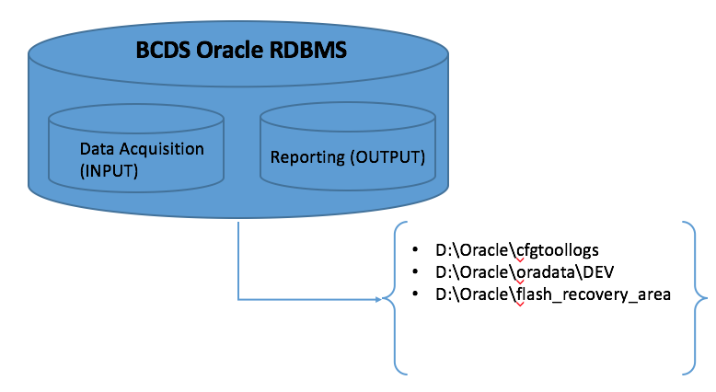

Non-DBMS Files
The BCDSS application will use NoSQL DBMS (MongoDB) to implement the model repository for managing and maintaining predictive models and their associated matrix data for calculating the accuracy of the rating. Figure 16 depicts which BCDS repository will be using the NoSQL/Non-DBMS files.

Figure 16 – Non - DBMS Files
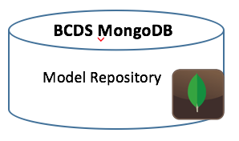

Data View
BCDSS Application has three core logical data repositories in support for the data lifecycle within the system.

BCDSS Data Ingest and Processing (INPUT)
Data Ingest & Processing (INPUT) Repository: This layer of the LDM describes all the business entities that will be used to ingest predictive models and matrix data for the model before processing any claim(s) against the predictive model. Figure 18, shows the LDM for managing the data ingest and processing within BCDSS.
Figure 18 – BCDSS Data Ingest

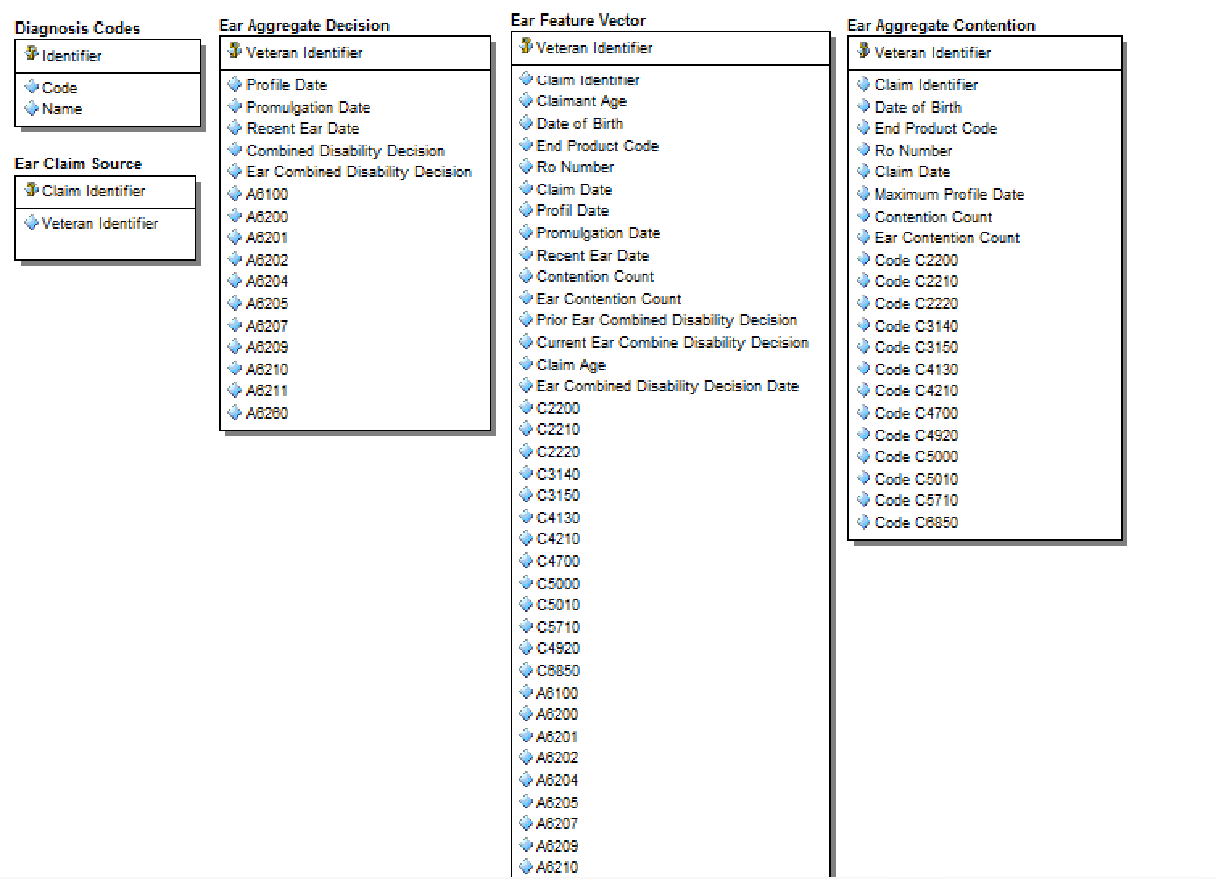
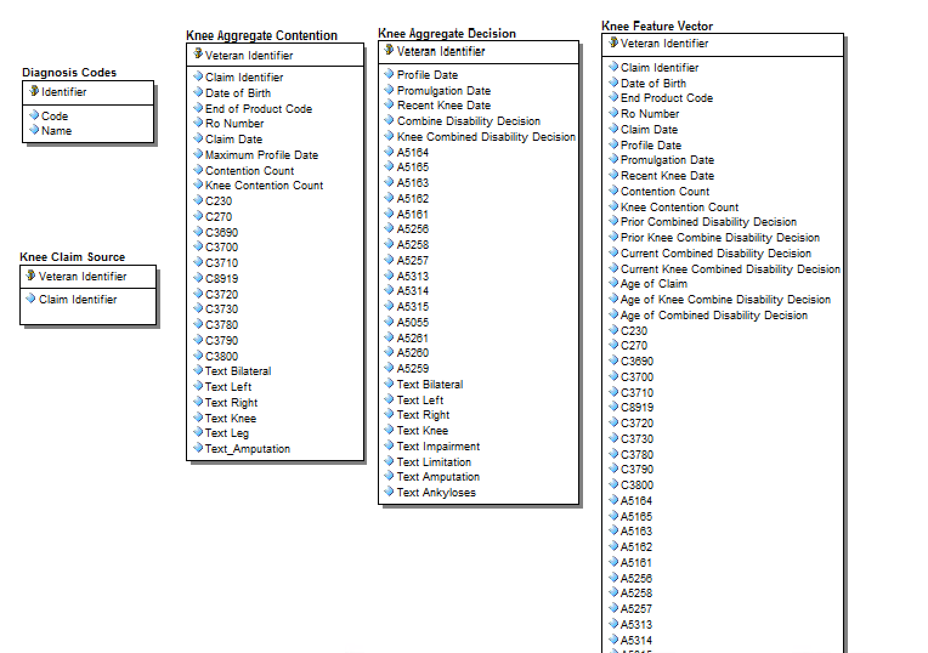

BCDSS Role Based Access Control (Model Repository)
The Figure 19, shows the logical data model for how the BCDSS application will manage and maintain security within the system. BCDSS will use the role based access control pattern, which will allow the system to track every user’s permissions, role, and actions.

Figure 19 – BCDSS Role Based Access Control
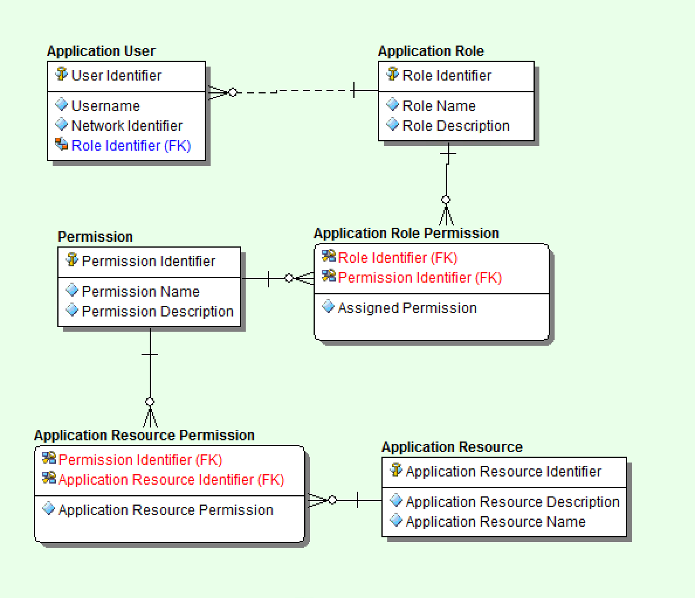

BCDSS Predictive Model Meta Data
The Figure 20, shows the layer of the LDM is used to track the properties and descriptive attributes of each predictive model. It does not include the run-time data supporting the model but rather the attributes used in the calculation of model results at run time.

Figure 20 – BCDSS Predictive Model Meta Data
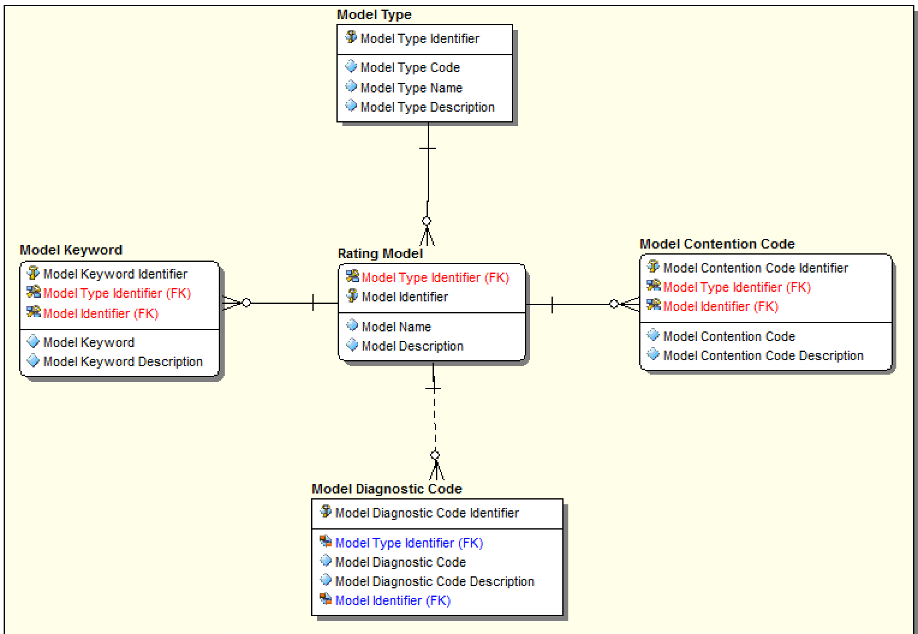

Detailed Design
The following section details each aspect of the BCDSS solution. This will be expanded to include each component of the solution as each are defined via the requirements process.

Software Detailed Design
The Software Detailed Design is used to define the detailed design for all components of the BCDSS application, which are specified in the requirements.
The web application provides access to all BCDSS business services through web-based user interfaces. The BCDSS web application is based on HTML 5, AngularJS, CSS and ReST services and is deployed on Tomcat container. AngularJS is a structural framework for dynamic web applications. It handles all of the DOM and AJAX code and puts it in a well-defined structure. The application incorporates usability features for individuals with disabilities and provide the BCDSS system with section 508 compliance.
The server side components of BCDSS application consists of client request processing, business logic, rules, and data transformation services.
Figure 21 shows high-level application component design of the BCDSS application.

Figure 21 – Application Design

Application Dashboard
The application dashboard displays the status of processed claims, Models, and various reports for the BCDSS application. The dashboard is designed as a Single Page Application (SPA), which loads as one HTML page which redraws its user interface without round trips to server. The client is a browser that runs JavaScript code to request the data and render updates to the page. The server is an API oriented architecture exposed through HTTP for items such as authorization, data access, business logic via CRUD (create, read, update, and delete). Node.js provides the base architecture for the web server providing the primary services of the dashboard through HTML, JavaScript, and CSS to drive the behavior of the application. The Figure 22 illustrates various components required to populate application dashboard to the application user.
- Node.js (JavaScript runtime engine)
- Express.js (Node.js module used to handle routing of HTTP calls)
- HTML, JavaScript, and CSS
- Angular.js (JavaScript framework for extending HTML)
- Bootstrap (powerful front-end framework for faster and easier web development)

Figure 22 – Application Dashboard

Server-side components
The application uses Node JS as server side technology that for handling HTTP request response processing. It uses Express JS for ReST based web service calls. Custom components of the application use Java and Spring technologies.

Manage Models
The BCDSS application allows users to make controlled edits to existing models within the system. The user identifies what models should be ingested into the system. The application provides Add, Update, Delete options for the models to authorized users. It uses angular JS framework to view the results and Hibernate/JPA for object relational database mapping. The Figure 23 illustrates the data flow to populate model information to the user from BCDSS database.
Figure 23 – Manage Models

Display Target Claims
The BCDSS application communicates with Mock web services for target claims data using a SOAP web service based on the user defined filter criteria. The Mock webservice response will be formatted to the BCDSS application format using data transformation service. Transformed data will be stored in BCDSS database and displayed on the application client’ page for user actions. The Figure 24 illustrates the data flow to populate target claims data to the user.
Figure 24 – Display Target Claims

Apply Models to Target Claims
The BCDSS application displays available models that the application user will then select to process and analyze the selected claims. The Figure 25 illustrates various components required for the apply models to the target claims data. The model conforms to BCDSS requirements by defining the specifications for the three core components of BCDSS models:

1) Decision Determination Matrix (DDM)
2) Target Claim Feature-Set Data and Computational Specifications
3) Claimant Feature-Set Data and Computational Specifications
Figure 25 – Apply Models to Target Claims

Reporting
The BCDSS reporting service offers useful features including matrices, ad hoc reports, custom report items and a variety of presentation formats such as PDF and CSV.
Types of reports include:
- Required standard reports
- Reporting histories for trending and monitoring of operational performance

Specific Requirements
For further details on the specific functional requirements of the system, please refer to the BCDSS Requirements Specification Document.

Security and Privacy

Security
This section provides the security design principles, patterns, and specific implementation details for BCDSS. This document may be updated to reflect changes to the design as required supporting the expanding enterprise requirements for information security.
The BCSS Security Design shall be discussed in terms of:
- Physical Security
- Network Security
- Transport Security
- Message Security
- Application Security

Physical Security
Addressing physical security is currently outside of the bounds of this document.

Network Security
Addressing network security is currently outside of the bounds of this document.

Transport Security
Transport security protects traffic between systems at the lowest software layer. When two systems communicate, first network connectivity must be established, and then the transport technology takes over.
Transport Layer Security (TLS) and Secure Socket Layer (SSL) are transport cryptographic protocols that protect IP communications. Both TLS and SSL rely on the Public Key Infrastructure (PKI) certificate that enables both the encryption of communication and authentication & non-repudiation of certified holders. The VA uses 128-bit certificates issued by VeriSign, Inc. Certificate Authority (CA) under the VA Intermediate CA.
Figure 26: Browser Transport Security
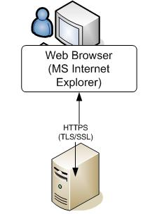

Figure 26 shows the application users connected to the VBMS Web Application with a web browser. The web browser uses Hypertext Transfer Protocol (HTTP) with TLS/SSL. The certificate of the server is provided to the browser which enables the user to verify the identity of the server as well as provide encrypted communication between the browser and the server. Encrypted traffic cannot be viewed by intermediate systems in the network chain.
While users interact with VBMS and other systems through a browser, many systems communicate directly with other systems and do not require a browser. Mutual Authentication TLS/SSL, often called two-way SSL, is required for system-to-system communications, figure 26.

Figure 26: Mutual versus Traditional TLS/SSL

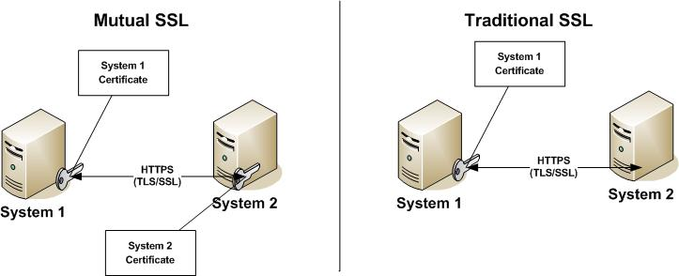
The primary difference between mutual and traditional TSL/SSL is that both systems require a trusted certificate presented during the protocol handshake. Both systems are able to enforce strict trust because both systems have authenticated. Mutual TLS/SSL provides an additional mechanism to protect unwanted network traffic from accessing the system.

Message Security
BCDSS, for the pilot phase, will not institute message level security. However, when entering the VBMS enclave, per the VA 6500 Information Security Handbook, the confidentiality and integrity of messages between systems becomes a requirement. To address these requirements the securing of a message is split into two concerns. The first, confidentiality, is achieved through encryption of the message itself. This is different from the notion of encryption of the tunnel, or transport, which is a point-to-point method vs an end-to-end solution. The second concern is integrity of the message, addressed by using digital signatures.

Application Security

Authentication
Authentication is the process of determining if a user or identity is who they claim to be. Typical information systems rely on internal authentication mechanisms that perform the authentication against an internal or locally defined user directory. Most common authentication mechanisms include the use of some form of credentials, like a username and password, a digital certificate (such as Public Key Infrastructure (PKI)), or a biometric identifier to prove the identity of a user or system. Using one of these authentication mechanisms, a user is able to prove they are in fact who they claim to be. BCDSS currently uses both a username and password as the credential set.
BCDSS is based upon HTTP Session Authentication within Spring Security. This state-full mechanism uses a token system stored within the server’s session context that is provided by the client’s cookie store. Longer state-full authentication, known as remember-me, within Spring Security parlance, is achieved through the storage of the token outside of session and inside of the static persistence container, currently Oracle.
When BCDSS enters into the VBMS enclave the authentication mechanism will implement the same standardized approach required of all the systems. In summary, this is a centralized authentication service, shared user directory, and SAML to facilitate security messaging.

Authorization Design
BCDSS currently uses Spring Security to implement a Role Based Access Control model. As detailed in the authentication section of this security model, user attributes are provided to a system as part of the authentication exchange. One of these attributes is a user role. A Spring Security User is created, and assigned this role. Enforcement of the authorization policy occurs within the UI through direct role checks and in the controller layer via Spring Security Annotations.

Privacy
Protecting the privacy of the veterans is a paramount concern for BCDSS, given the sensitive nature of the medical information that BCDSS receives and processes. BCDSS employs a number of design concepts to protect privacy. Sensitive information is scrubbed from URLs by using HTTP POST to send this data as opposed to sending data via URL parameters. To ensure adherence to standards during development Open Web Application Security Projct (OWASP) tools measure security weaknesses. Once BCDSS exits the pilot phase, PII/ Protected Health information (PHI) data becomes an issue and additional measures will be implemented to further ensure privacy. An example of this is full encryption of messaging between the server and end-user. Specific to the VBMS enclave is the adherence to same station rules within the Benefits Gateway Services (BGS) to control information access.

Human-Machine Interface

Interface Design Rules
The user interface shall comply with VA standards, guidelines, Privacy Rules, and section 508 requirements.

Inputs
BCDSS is a web-based system. All input occurs through the application’s standard HTML 5 interface. Messaging between the user browser and the BCDSS server(s) will occur using standard TCP/IP. Security of messaging will followthe VA standards. The use of user roles control access to areas of the BCDSS system, including all user interfaces.

User Roles
The Table 9 describes application user roles and responsibilities.
Table 9: User Roles
User Class | Description
Model Agent | Identifies what models should be “ingested” into the system  Executes routine that verifies that a new model conforms to system specifications  Makes controlled edits to existing models within the system
Rater | Selects – from those available within the system – the target set of claims data to which models will be applied  Selects - from those available within the system – where and in what format modeling results will be output  Applies the models under the control of the system
Administrator | Authorizes – from profiles available within the system - user access and privileges  Defines where and in what format, new models are readied for conformance testing and ingest  Defines what target claims data are available for modeling  Defines what formats and destinations are available for modeling results

Outputs
Outputs include data displayed on a web-based Dashboard, data sets resulting from application of models against claim data, as well as, generated reports.

Navigation Hierarchy
The BCDSS User Guide will provide detail regarding interfaces, navigation, and expected behavior. Additionally, this section will be updated as the UI/UX is designed and approved based on defined application requirements.

Logon
The Figure 27 illustrates user logon screen.
Figure 27 – Logon Screen

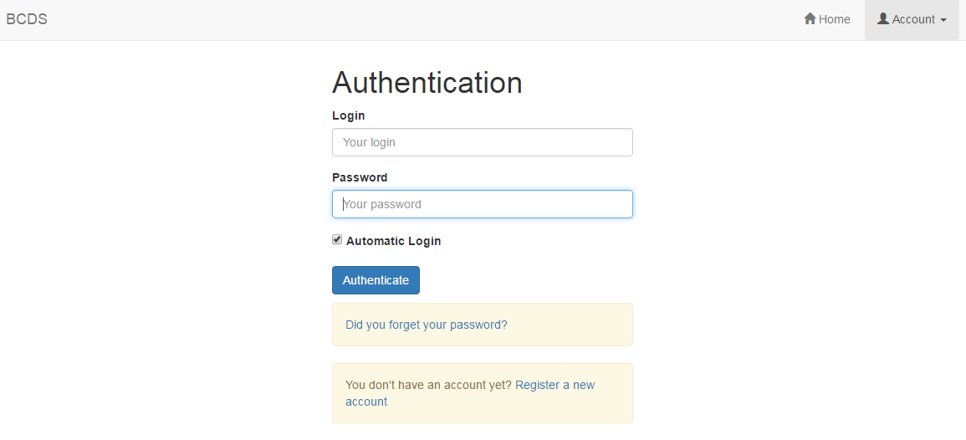

The Table 10 describes logon screen fields.
Table 10: Log on Screen fields

Field | Description
Login | User name to be authenticated.
Password | Password to be hashed and compared.

Adjudication Start
The Figure 28 illustrates adjudication process start screen.

Figure 28 – Adjudication Start Screen

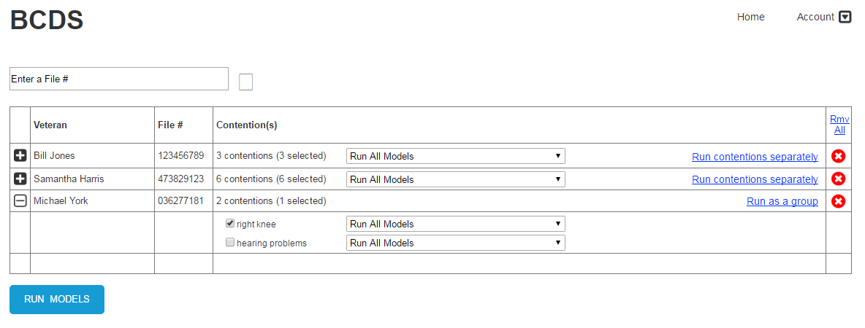

The Table 12 shows required fields for the adjudication process start screen.
Table 11: Adjudication Start Screen fields

Field | Description
Search File # | Veteran’s file number to be pulled for use in adjudicating claims.
Veteran | The Veteran’s name, retrieved from search.
File # | The Veteran’s file number, retrieved from search.
Contention(s) | List of contentions available in Veteran’s file.
Run All Models | Selection of models that apply to specific Veteran file.

Adjudication Results
The Figure 29 illustrates adjudication process results screen
Figure 29 – Adjudication Results Screen

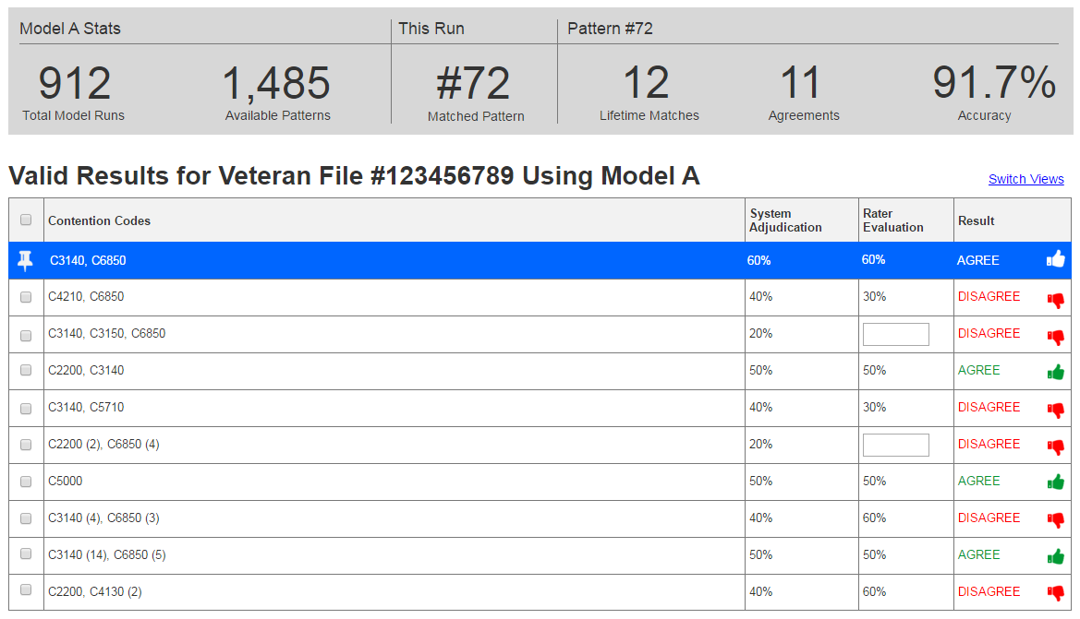
The Table 12 describes various fields required for adjudication process results screen.

Table 12: Adjudication Results Screen fields
Field | Description
Total Model Runs | Total Model Runs
Available Patterns | A model is a composite of many unique patterns that can be compared to a given instance.
Matched Pattern | Which unique pattern was determined as the adjudication
Lifetime Matches | How many times the specific pattern was matched.
Agreements | How many times was the statistical adjudication chosen as correct.
Accuracy | Agreements divided by Lifetime Matches for a given pattern instance.
Contention Codes | Contention Codes used as input.
System Adjudication | The resulting percentage as determined by the BCDSS system.
Rater Evaluation | Either the retrieved rating from VBMS-R or the ability to add a rating manually.
Agree/Disagree | Does the statistical adjudication match the rater evaluation?

Acronyms and Abbreviations
Table 14: Acronyms and Abbreviations
Acronym | Term
VA | Veterans Affairs
BCDSS | Benefit Claims Decision Support System
OWASP | Open Web Application Security Project
SDD | Software Design Document
PMAS | Project Management Accountability System
SOA | Service Oriented Architecture
CDD | Combined Disability Determination
UI/UX | User Interface / User Experience
VACI | VA Center for Innovation
SQL | Structured Query Language
CRUD | Create , Read , Update , Delete
RDBMS | Relational Database Management System
DBMS | Database Management System
HDFS | Hadoop Distributed File System
APIs | Application Interfaces
JPA | Java Persistence API
CSS | Cascading Style Sheet
HTML | Hypertext Markup Language
ReST | Representational State Transfer
DOM | Document Object Module
AJAX | Asynchronous JavaScript and XML
WS-I | Web services Interoperability
WSDL | Web Services Description Language
ESS | Enterprise Shared Services
TRM | Technical Reference Model
RBAC | Role Base Access Control
LDM | Logical Data Model
CDM | Conceptual Data Model
KPIs | Key Performance Indicators
SPA | Single Page Application

Approval Signatures
This section is used to document the approval of the Software Design Document. The review should be conducted face to face where signatures can be obtained ‘live’ during the review. If unable to conduct a face-to-face meeting then it should be held via LiveMeeting and concurrence captured during the meeting. The Scribe should add /es/name by each position cited. Example provided below.
The Business Sponsor and Project Manager are required to sign.

______________________________________________________________________________
Signed: Date:
< Business Sponsor >

______________________________________________________________________________
Signed: Date:
< Project Manager >

- Additional Information
  - Identification of Technology and Standards
Standard | Reference
National Institute of Standards and Technology (NIST) Special Publication (SP) 800-53 Revision 2 for the Federal Information Security Management Act (FISMA) compliance | http://www.nist.gov
NIST SP 800-27 | http://www.nist.gov
NIST SP 800-53 Revision 3 | http://www.nist.gov
Section 508 | http://www.section508.gov/
Section 508 Checklist for Software Applications and Operating Systems | http://www.section508.va.gov/docs/checklist_1194_21.pdf
Section 508 Checklist for Web-based Internet Information | http://www.section508.va.gov/docs/checklist_1194_22.pdf
VA Policy and Handbook 6500 | http://www1.va.gov/vapubs/viewPublication.asp?Pub_ID=56

Technology | Version
Spring Framework | 4.1.6
jQuery | 2.1.4
AngularJS | 1.4.5
Hibernate | 4.3.9
Representation State Transfer (REST)
Spring Boot | 1.2.4
Spring Security | 4.0.1
Security Assertion Markup Language (SAML) | n/a
Web Services Security for Java (WSS4J) | n/a
Logback | 1.1.3
Oracle | 11g
Tomcat | 7.0.68
Jenkins | 1.6.50

- Constraining Policies, Directives and Procedures
This document is based on the SDD template from ProPath. Creating the SDD is part of the process of determining requirements during project planning. ProPath guidance expects the SDD to come before (or at the same time as) the Project Management Plan (PMP). The policy is to follow the PMAS version 5.0+ and the ProPath version 9.0+ processes and documentation.

- U.S. Department of Veterans Affairs (VA) Project Management Accountability System (PMAS) ProPath Guidelines;
- VA’s interpretation of Section 508 of the Rehabilitation Act of 1973 as governed by the VA Section 508 Office and documented on the Section 508 Office Web Page;
- Privacy Impact Assessment—Privacy Service;
- Federal Information Security Management Act (FISMA);
- VA Directive 6500 Directive and Handbook, Information Security Program;
- VA Handbook 6221, Accessible Electronic Information Technology (EIT);
- National Institute of Science and Technology (NIST) 800-53;
- Federal Information Processing Standards (FIPS); and
- Continuous Readiness in Information Security Program (CRISP).

- Requirements Traceability Matrix
The BCDSS RTM CLIN0002AB that traces modules and data structures to the software requirements has been provided below and in delivery to the VA along with this document at the same time. It is a Living Artifact and will be added to/ updated at each stage though the lifecycle.
Click here for latest RTM document

- Packaging and Installation
Build scripts orchestrate the compilation of source code, execute unit testing, create code coverage reports, and automatically deploy into development integration environment. An automated build framework not only helps solve integration issues early, but also helps build and deploy the complex products quickly, all while ensuring that the build processes are transparent, auditable and repeatable.

